Dental Analyzer Documentation

# Overview

Dental Analyzer is a tool to evaluate metrics of digital crown prep models. These metrics can be compared to their ideal values, in order to determine how well the crown model is prepared. This documentation includes a tutorial of how to download and use the tool, as well as more details of how each metric is computed at the end.

# What Dental Analyzer computes

|  |  |
| --- | --- |
| Metric | Definition |
| Shoulder width | Distance between margin line and axial line |
| Axial Wall Height | Distance between axial line and occlusal line |
| Taper | Half of total occlusal convergence, which is the angle formed between opposing axial walls |
| Margin Depth | Distance between axial walls of student prep and original prep, at 0.5mm above the margin line |
| Occlusal Reduction | Distance between occlusal of student prep and original prep |
| Gingival Extension | Distance between the margin line and gingiva line |

# How to download Dental Analyzer

The installer is available in the following link: <https://drive.google.com/file/d/1Z_LomSJdLxnflsJ0CzNR-8mJ562NfFXX/view?usp=sharing>

Follow the instructions of the installer to install Dental Analyzer on your computer.

Note: If the application is missing VCRUNTIME libraries, try to run the *VC_redist.x64.exe* in the installation folder to get necessary libraries.

# 

# Tutorial: How to prepare the data for Dental Analyzer

1. Before using Dental Analyzer, we need to do some preprocessing on the student prep and original prep. MeshLab is included in the installation package of Dental Analyzer. Assuming you are installing Dental Analyzer at C:\Program Files (x86)\Dental Analyzer, you can open MeshLab at C:\Program Files (x86)\Dental Analyzer\MeshLab\meshlab.exe

2. Open MeshLab. Import **original prep model** by clicking Files->Import Mesh. Or you can import the model by directly dragging the mesh file to the MeshLab interface

3. After importing the original prep, the first thing is to check that its y axis aligns with the ‘up’ direction (the direction where the tooth points) of the prep. This is an important step because Dental Analyzer assumes the ‘up’ direction of the prep to be the positive y direction. In this example, we see that the original model is not facing up.

We perform the following steps to align the ‘up’ direction with the y-axis:

First, use Filters->Normals, Curvatures and Orientation->Transform: Align to Principal Axis to align the ‘up’ direction of the prep to one of the axes (not necessarily the y axis).

Below we see that the ‘up’ direction has been aligned with the negative x axis.

Then we will use Filters-> Normals, Curvatures and Orientation-> Transform: Flip and/or swap axis to make ‘up’ direction positive y-axis. If you are unsure what options to choose when changing the axis, try different combinations and click ‘preview’ to see the results, without applying the transformation directly.

After aligning the model with the y-axis, click apply and close the box. Export the mesh in .OFF format in File->Export Mesh As… The .OFF format prep model is what the Dental Analyzer takes as input.

4. Then we need to mark the lines (gingiva line, margin line, axial line, occlusal line) on the **student prep model**. These lines are required as input to Dental Analyzer. We will mark margin lines on the student prep model as an example.

Meshlab does not have tools to mark lines on the model. To get around this, we will mark a set of points on the model using the PickPoints  utility. You can find this tool near the middle of the tool bar in the MeshLab UI.

Open the .OFF file we saved for the student prep model in step 4, click on the PickPoints utility in the tool bar, a window should open on the upper-right corner of the screen.

Untick the ‘Show Normal’ option at the bottom of the window, since we are not interested in normal of the points. Use right click to pick points, and if you want to move or rotate the model, use ‘Esc’ to toggle between PickPoints mode and normal mode. It is important that you pick points in a way that current point is next to previous point, i.e. you should pick points sequentially in space.

After finishing picking the points, save it as .pp file. Then, remove all the picked points in the window, and repeat the process for each of the four lines (gingiva line, margin line, axial line, occlusal line).

6. Next, we will find the transformation matrix that aligns the student model to the original prep model. Import the student prep model and original prep model (aligned to y-axis in step 3). Click on the Alignment tool  on the toolbar, and a window should pop up.

Since we want to align the student prep model to the original prep model, we will ‘glue’ the original prep model at its current place. Click the name of the original prep model in the window, and click ‘Glue Here Mesh’. An asterisk * should appear near the name of the original prep model.

Then we will align the student prep model with the original prep model. Click the name of the student prep model, and then click ‘Point Based Glueing’, a new window should pop up.

Select at least 4 matching pair of points on the two meshes. Double click to add points on each mesh. After finishing selecting the points, click OK, and the result should be similar to the following.

If you have more than one student prep models, you can use ‘Point Based Glueing’ on each of them and align them all at the same time.

Then, click ‘Process’, and MeshLab will further improve the alignment based on the ‘Point Based Glueing’ results.

Now all models have a position matrix that is different from the identity matrix. Since we want to assign the identity matrix to the original prep model, click the name of the original prep model, and click ‘Set as Base Mesh’. This will assign the identity matrix to the original prep model.

Now we are done with the alignment, close the alignment window and save the project as .ALN file by clicking File->Save project as and choose the .ALN format.

The .ALN file should be a text file that looks like the following. We see that the transformation matrix is included in the file, and we will use the transformation matrix in Dental Analyzer.

# Tutorial: How to use Dental Analyzer

1. Open the DentalAnalyzer, you should see an interface like the following

The UI consists of 3 sections: Inputs, Outputs and Feedback.

In the ‘Input’ section, you need to input the file as requested. These files should be prepared according to the tutorial in the previous section (“How to prepare the data for Dental Analyzer”).

Note: The first entry is optional. If you specify the location of the folder containing the files, it will fill out the rest of the entries (except ‘Original Model’) using the format StudentFolder/DefaultName, the default name for each of the entry is as follows:

Model – model.off

Margin Points – margin_points.pp

Axial Points – axial_points.pp

Occlusal Points – occlusal_points.pp

Gingiva Points – gingiva_points.pp

Center – center_point.pp

Midpoint – mid_point.pp

If you want to divide the crown prep into 4 regions (Lingual, Buccal, Mesial and Distal), you can select the ‘Enable Region Division’ option, and you have to provide the center and midpoint of the student model, each as a .pp file.

Illustration of midpoint and center is as follows. They are used to determine the direction of a tooth, i.e. Lingual, Buccal, Mesial, Distal.

For the alignment method, select the ‘Manual Alignment’ and copy the alignment matrix from the .aln file from the previous tutorial. Below is an example after filling the inputs.

If you are finished with inputting the files, click on ‘Analyze’ to start the analysis, the results should be available in the ‘Output’ section.

After taking a look at the outputs, you can write your feedback in the ‘Feedback’ section and save it as a .txt file. You can also record audio feedback with ‘Record Audio Feedback’, and a new window should pop up.

# Details about algorithms to compute each metric

* Shoulder Width
  + Per-vertex value on the axial line
  + For each point $P_{2}$ on the axial line, find the closest point $P_{1}$ on the margin line. Compute the distance between these two points, and the distance is an estimate of the shoulder width. By averaging the result over all points in one section, we get the shoulder width for that section.

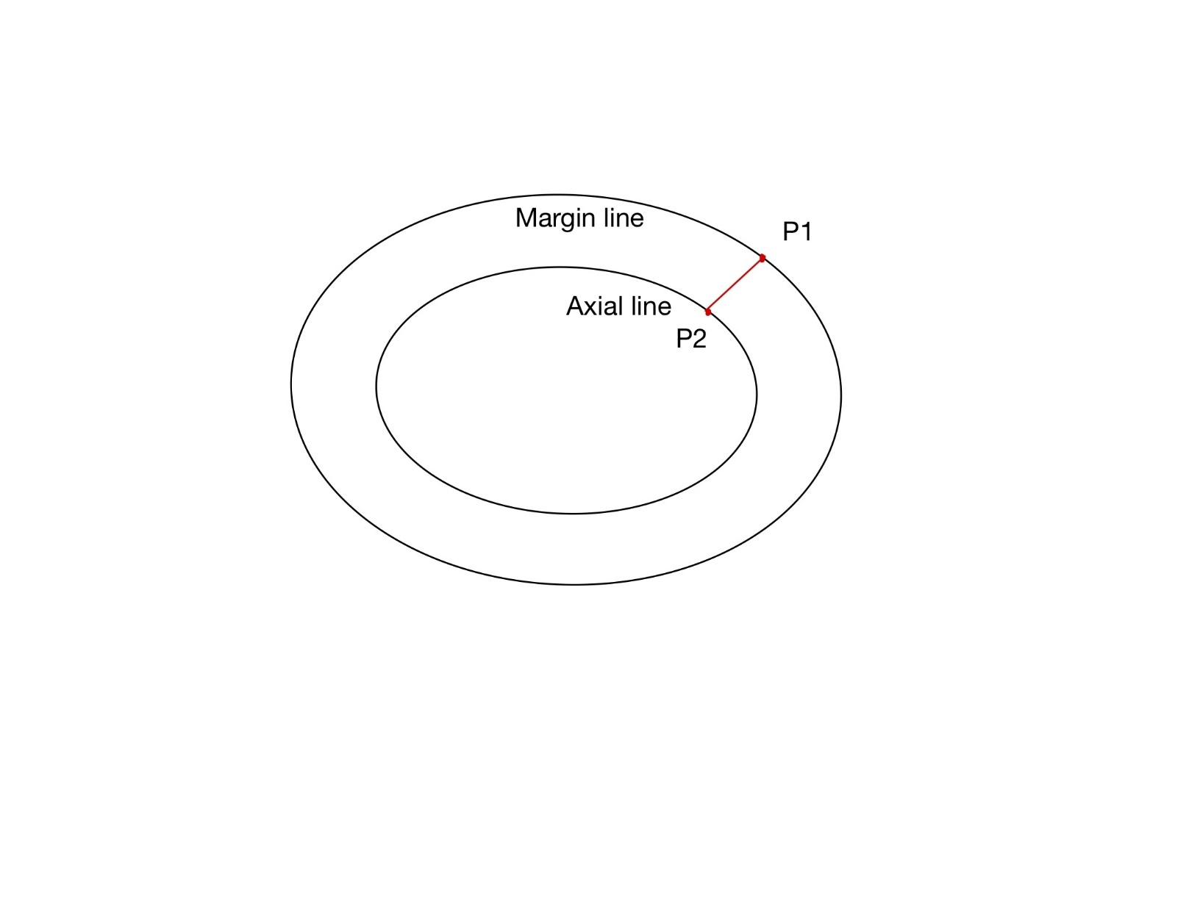

* Axial Wall Height
  + Per-vertex value on the occlusal line
  + For each point $P_{1}$ on the occlusal line, find a point $P_{1}'$ on the axial line which forms a line $P_{1}P_{1}'$ that has the smallest angle to the vertical y-axis. The line $P_{1}P_{1}'$ formed by these two points approximates the axial wall. The distance ${|P}_{1}P_{1}'|$ is the axial wall height. Again, we average this value over all points in one section.

* Taper
  + Per-vertex value on the occlusal line
  + For each point $P_{1}$ in the occlusal line, firstly we use similar methods as we used for Axial Wall Height to find axial wall approximation $P_{1}P_{1}'$. After getting $P_{1}P_{1}'$, we are doing an extra step to approximate the axial wall: find the midpoint of $P_{1}P_{1}'$, denoted as $P_{m1}$. We then find the closest point $P_{m1}'$ on the model, then we use the line $P_{1}'P_{m1}'$ as the axial wall approximation. It can be explained by the following picture:

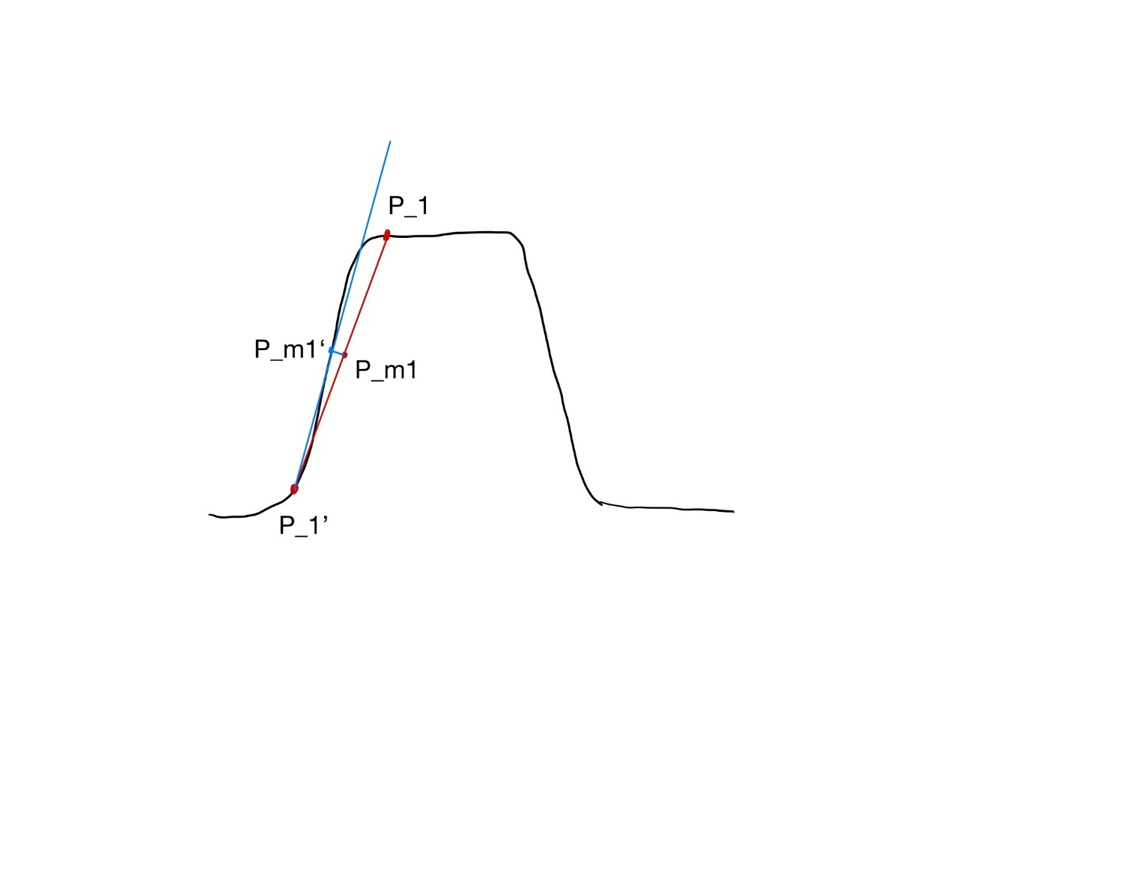

We see that blue line is a better approximation of the axial wall than the red line.

* + Then we find the opposing axial wall to it, i.e., the axial wall on the far side of the tooth. To achieve this, we first find the average of (x,z) coordinate of the occlusal line, and this average is an approximation of the center of the tooth (denoted as $P_{center}$). Then we iterate over points on the occlusal line and find the point $P_{2}$ that forms the largest angle .

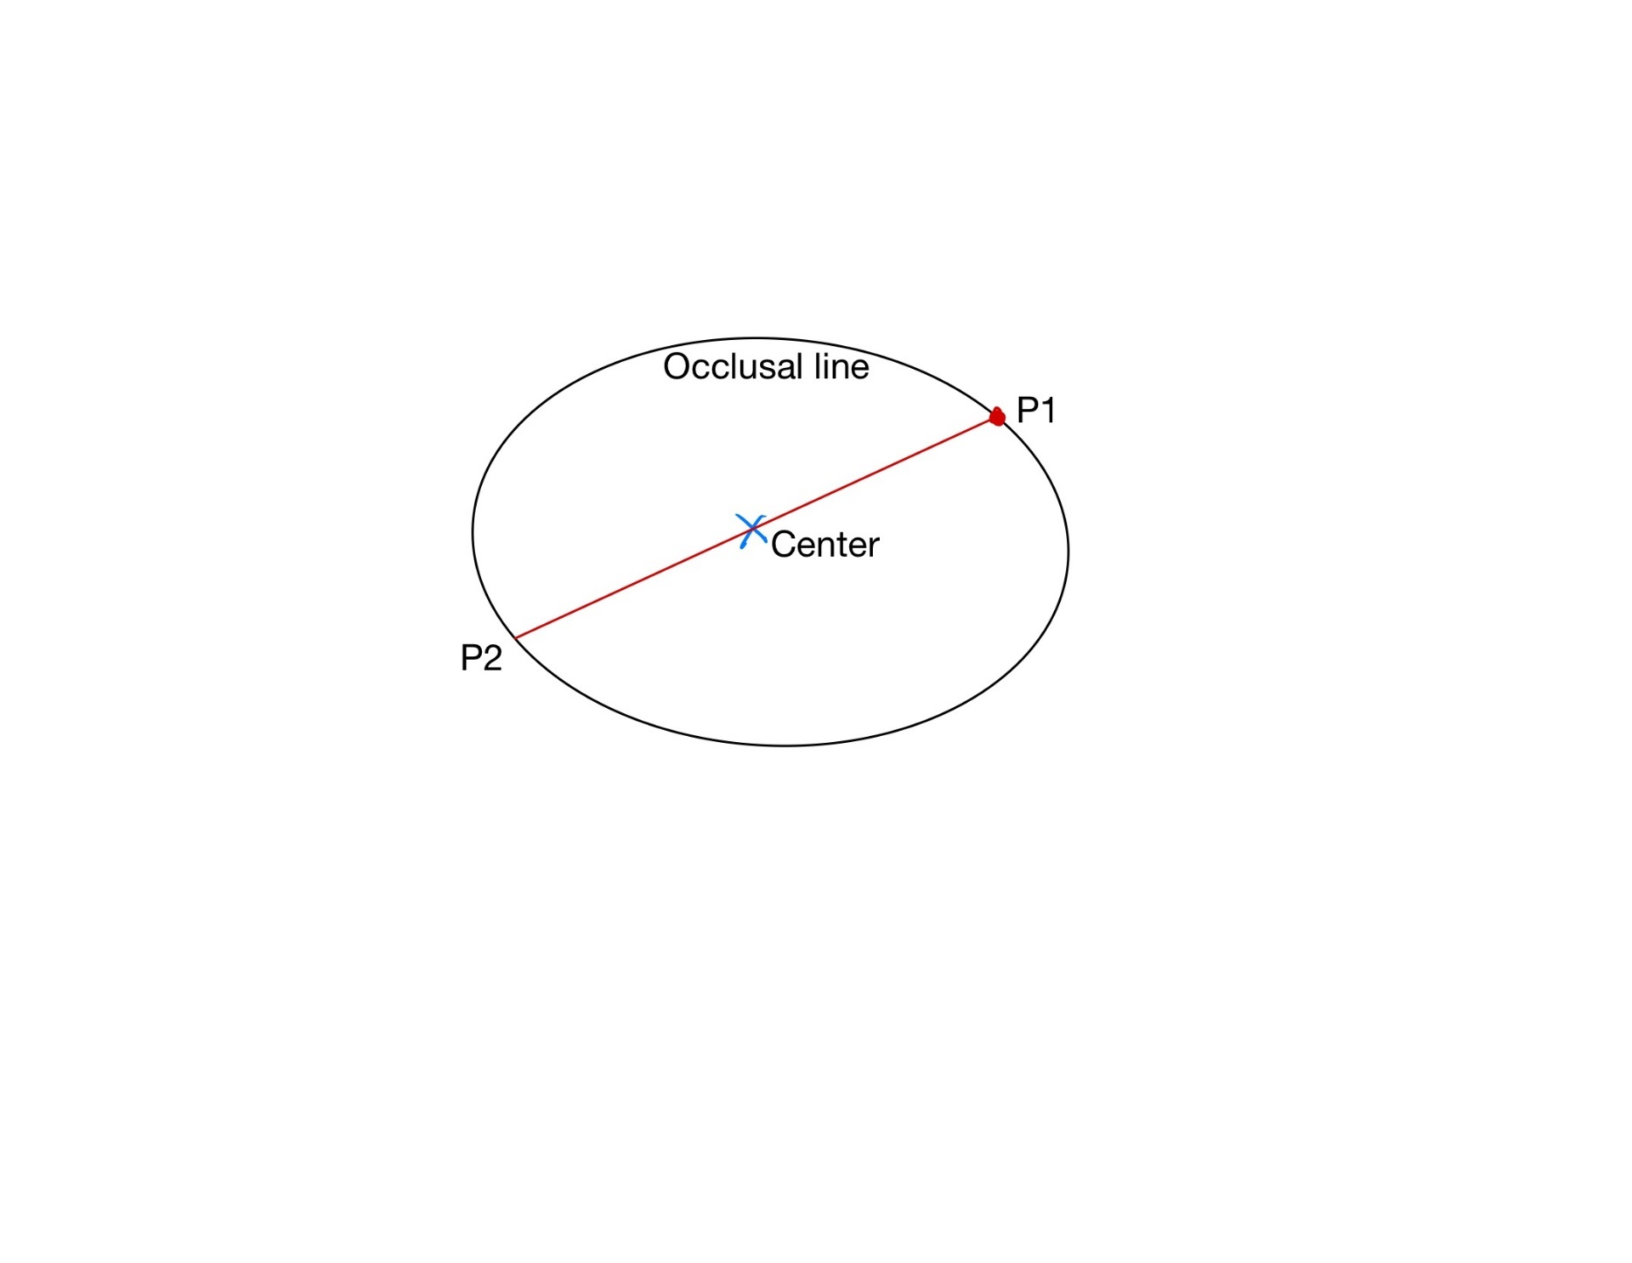

* + Then using the same method to find axial wall approximation at $P_{2}$, which should be $P_{2}'P_{closest_to_midpoint_2}$, and the angled formed by the axial wall at $P_{1}$ and $P_{2}$ is the Total Occlusal Convergence, and we divide TOC by 2 to get Taper.
  + By averaging result over all points on the occlusal line in one section, we get taper for that section.
* Occlusal Reduction
  + Per-vertex value on the occlusal
  + For each point $P_{1}$ on the occlusal of the student model, compute its shortest distance to the original model. By averaging the result for all vertices in one section, we get the occlusal reduction for that section.

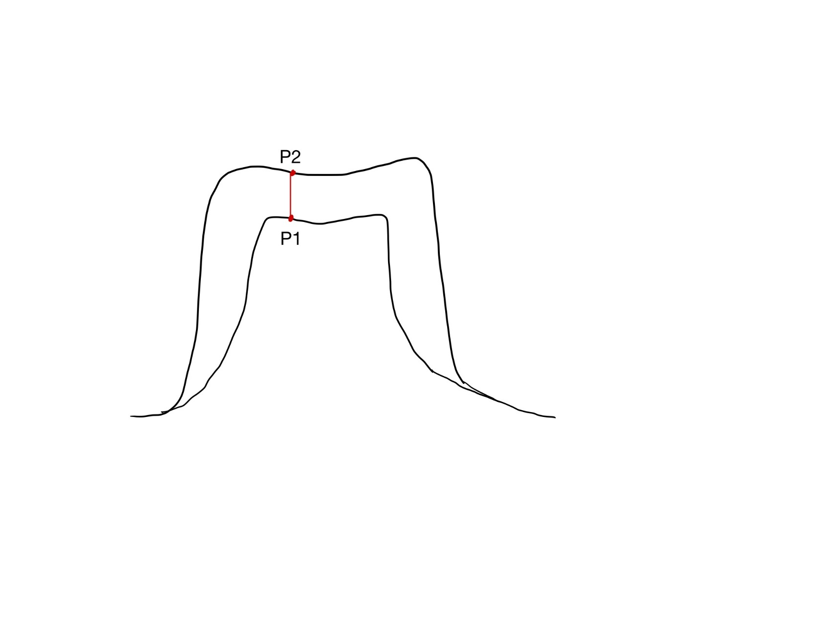

* Margin Depth
  + Per-vertex value on the margin line
  + For each point $P_{1}$ on the margin line, add ½ mm to its height to get a new point $P_{1}'$.
  + Find the closest point $Q$ on the original model to the point $P_{1}'$.
  + Find the closest point $R$ on the original model to the point $P_{1}'$.
  + The distance $|QR|$ is the margin depth at this vertex.
  + We average this value over all points in one section.

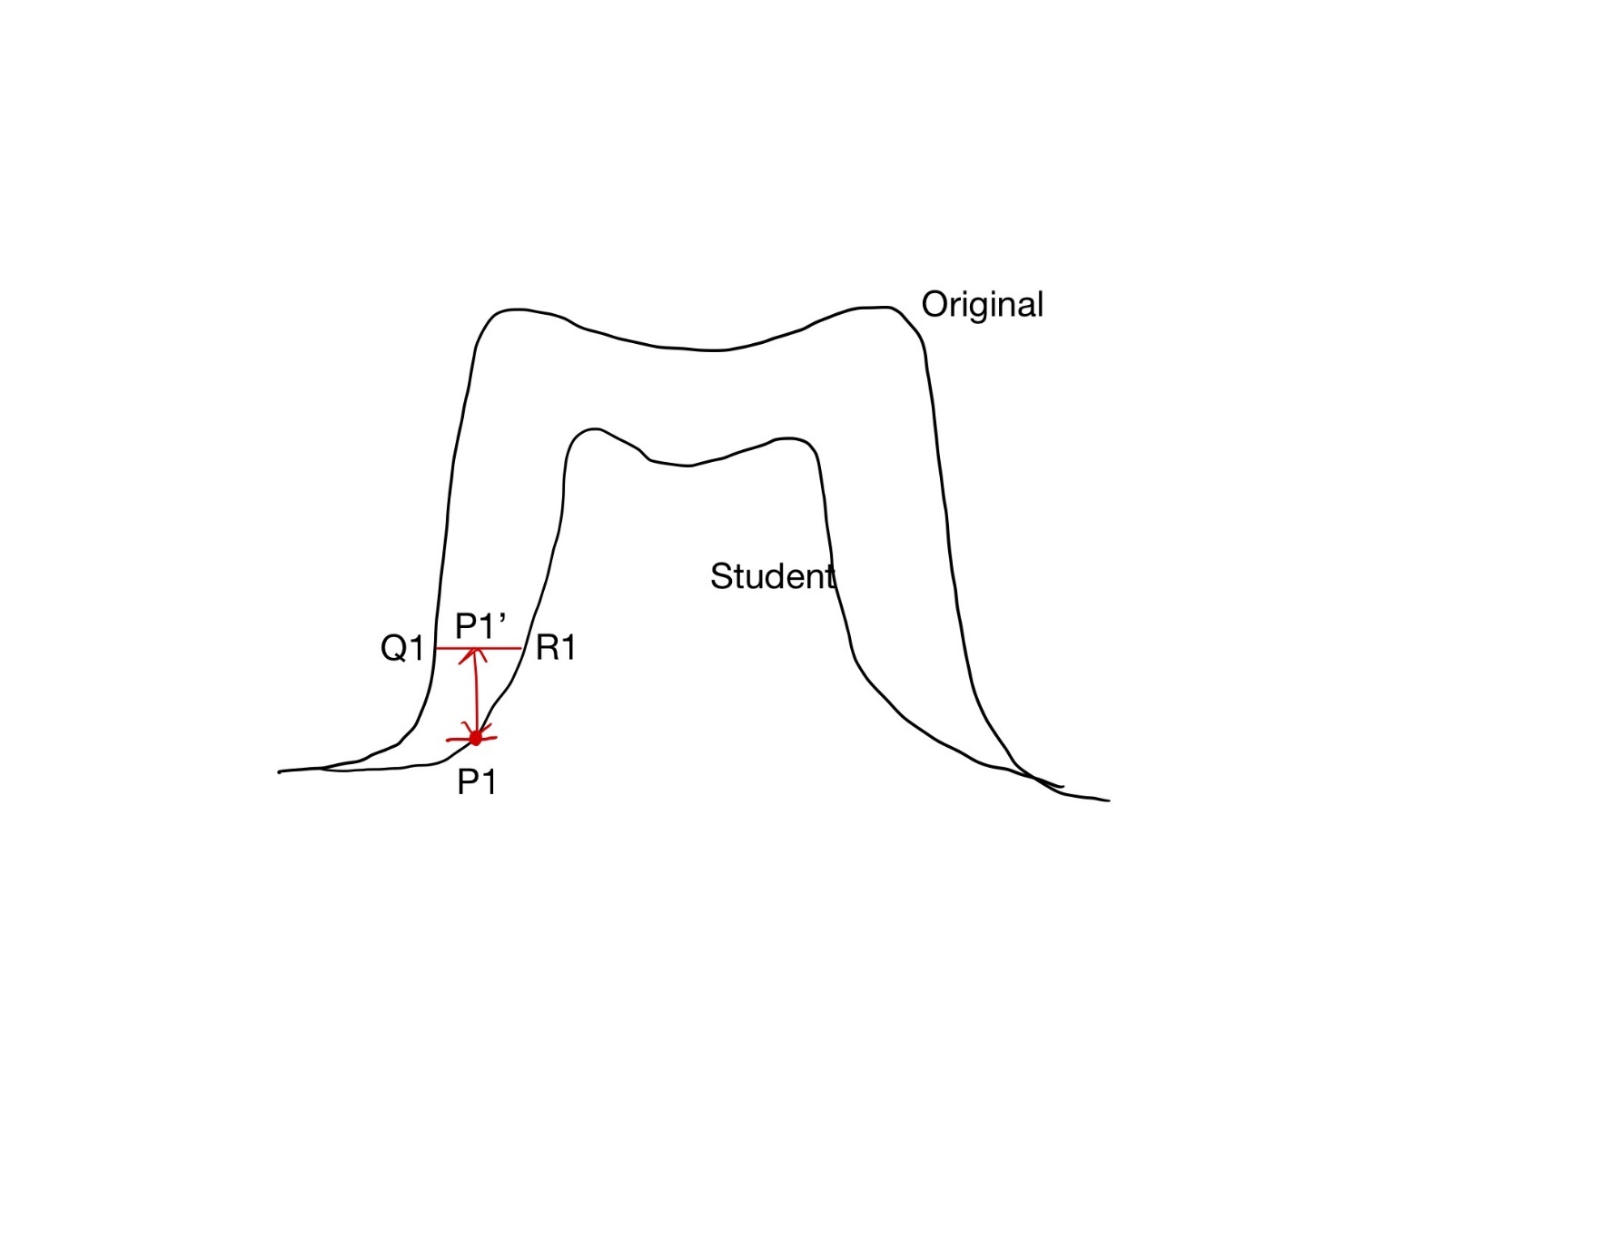

* Gingival Extension
  + Directly find the difference between the average height of the points on margin line and points on gingival line of the student model in each section.